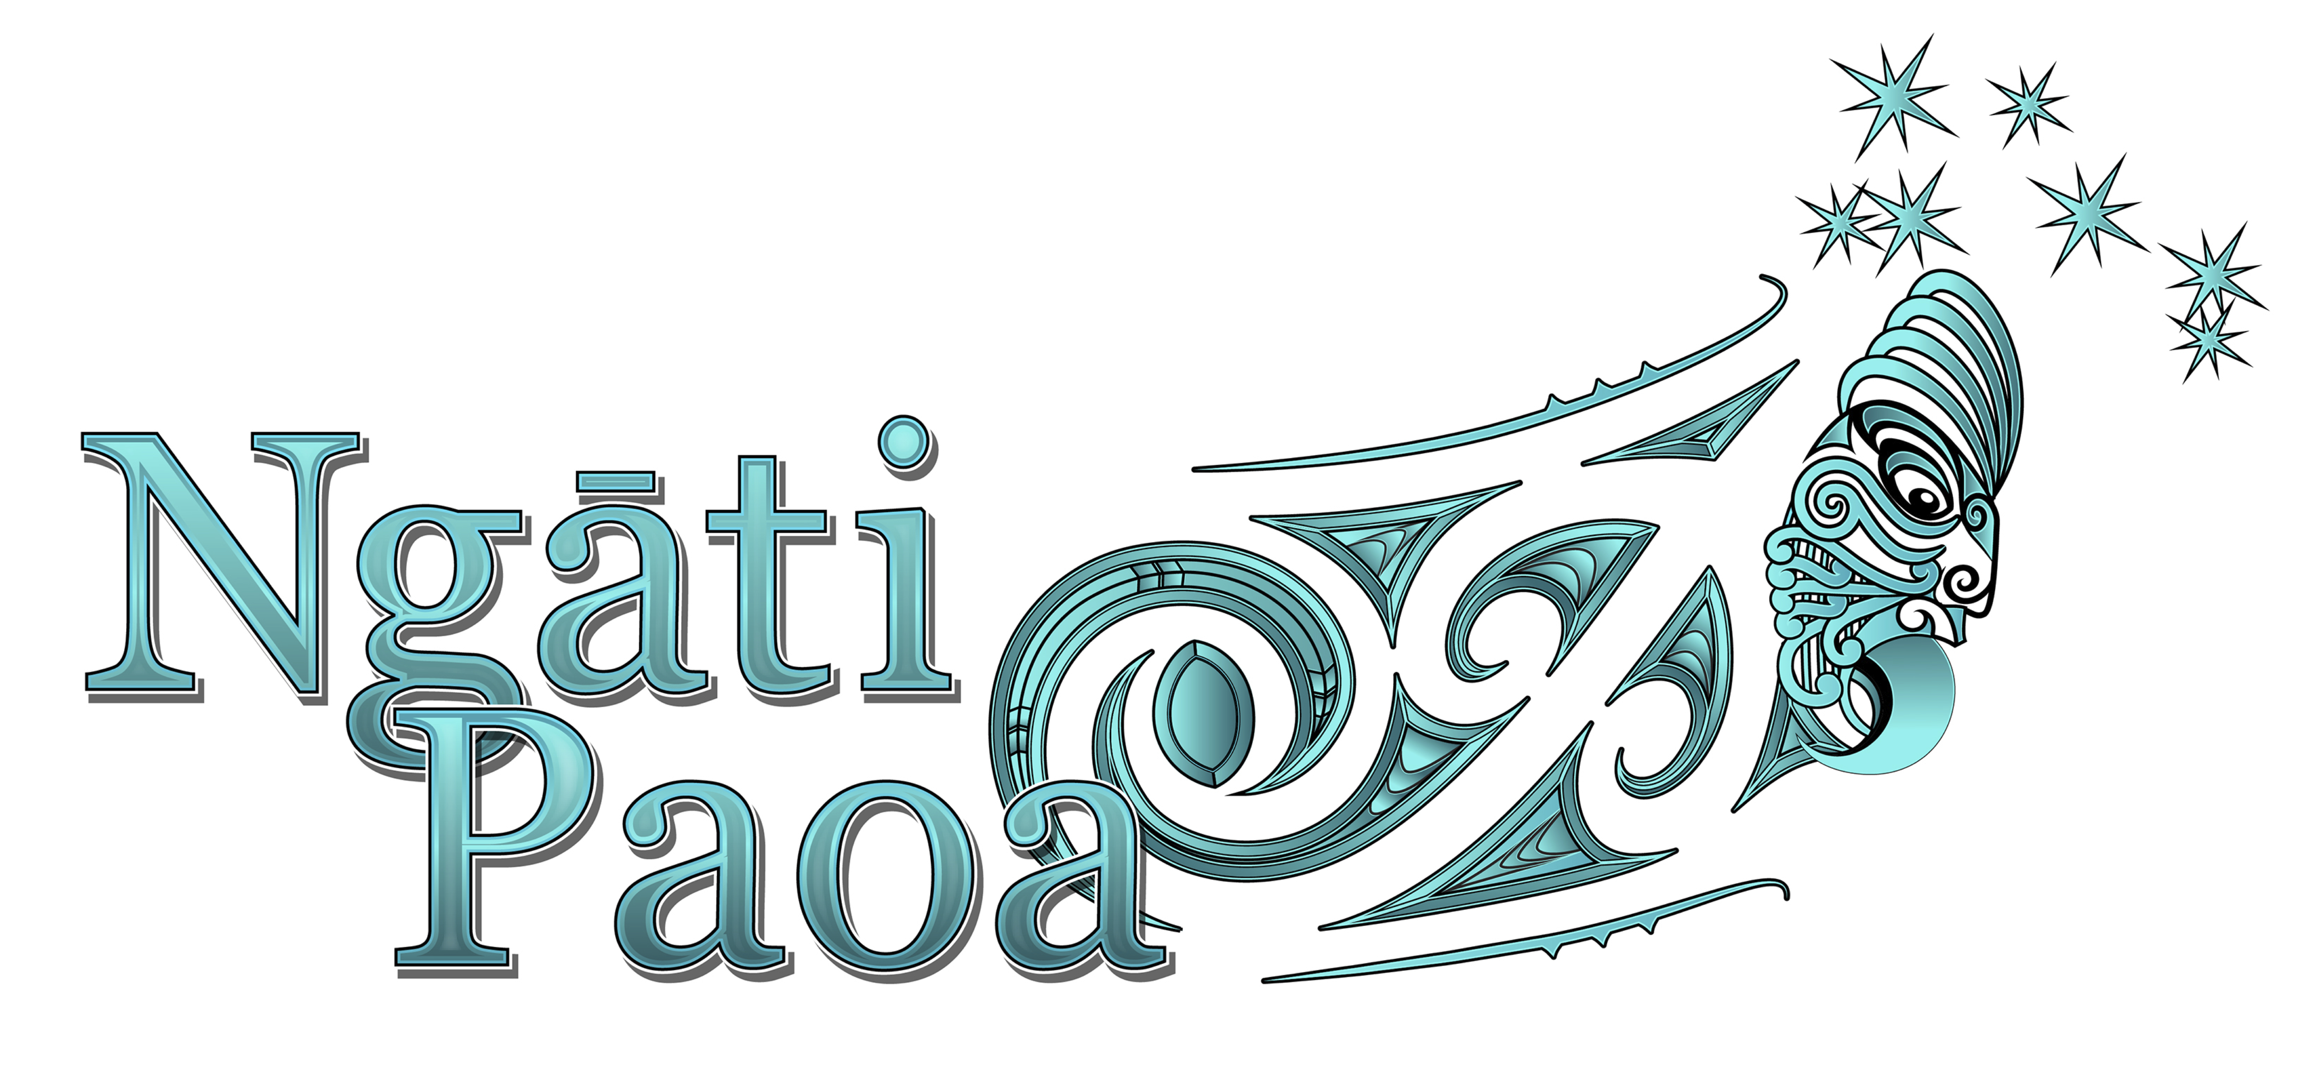

Pānui
Kia ora Paoa Peeps
Time for a major catch up - so many things have happened since the start of 2017! Here are the major items of news you should know about:

- Iwi Housing Development: First, congrats to Pare Hauraki Iwi and Te Temu Kainga on the launch of their housing development at Whenuapai. Check out the full story here . We here at the trust office couldn’t help but smile at Paul Majurey’s comment about it being a sign of the changing face of New Zealand and of the progress we are making from being landless to landlord.
We are planning that’s what Ngāti Paoa will be saying once we get our proposed housing project underway at Pt England! For now we are awaiting the report of the Parliamentary Select Committee that is considering submissions about the 11.69 ha of land Pt England Reserve being offered for us to buy. The 2ha marae site is separate and cultural redress. That report’s due late April. All going well we then wait for legislation to pass and start negotiations over buying the land. We will keep you posted, but some stuff will be commercially sensitive and under wraps for a while.

- Signing our Settlement: Please note Minister for Treaty Settlements Chris Finlayson has confirmed that our two principal negotiators, Hauauru Rawiri and Morehu Wilson, hold the mandate for Ngāti Paoa to initial the Settlements for Marutuahu and Ngāti Paoa. Minister Finlayson has sent a letter to that effect.

- High Court Action 1: By now some of you may have heard that Justice Davison in the Auckland High Court has turned down an application by Ngāti Whātua Ōrākei to stop the transfer of land in central Auckland to other iwi, including Ngāti Paoa, as part of their settlements. You can read a Te Manu Korihi -Radio NZ story here .
Ngāti Whātua Ōrākei has indicated that it will appeal, so the judgement is no longer on line to read. Your team remains focused on reaching Settlement. We are working with Ngāti Whātua Ōrākei, guided by the Kawenata we signed together earlier this year that commits us both to act in a way that is tika and pono (doing the right thing, in the right way) and that respects each other’s mana.

- High Court Action 2: Ngai Tai Ki Tamaki Tribal Trust took the Minister of Conservation to court over who should be able to run public tours and provide information that includes historical facts about the islands. Justice Fogarty did not overturn five year concessions for the Motutapu Island Restoration Trust and for Fullers to take tours to Rangitoto and Motutapu Islands. Although the judge did find the Ministry had erred in law on one hand, its decisions to grant the concessions did give effect to the principles of the Treaty on the other.
Ngati Paoa was a participant in the hearing. Our arguments were on matters of principle and law (not the facts of the case). The decision largely reflects the arguments that Ngāti Paoa put to the Court, which included that Ngāi Tai may have a priority interest in Motutapu but not exclusive Interests.
You can read the full judgment here

- Hauraki Collective voting: Voting closes today with official results announced on March 20. Watch this space!

- Ngāti Paoa AGM: This was postponed due to the Hauraki Fisheries AGM being held on the same day. The date will be reset and we will provide more information when that is confirmed.

As you know the team has been involved in lots of other activities. We appreciate your support and willingness to participate. If you know of any family who have yet to register with the iwi trust, please encourage them to do so.

Ngā mihi manahau
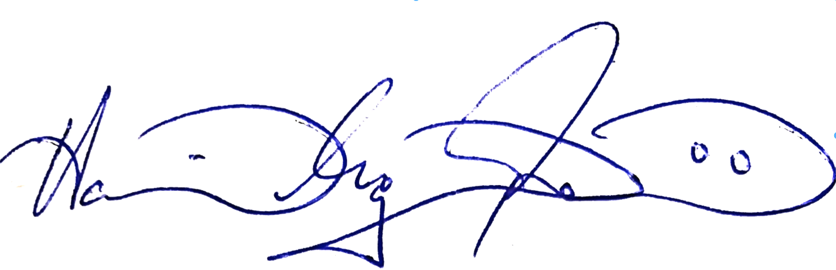

Hau Rawiri (Hauāuru)
Kaihautū - CEO, Ngāti Paoa Iwi Trust

