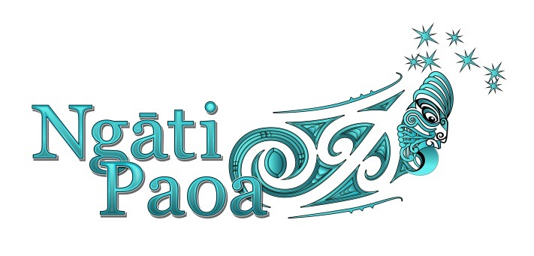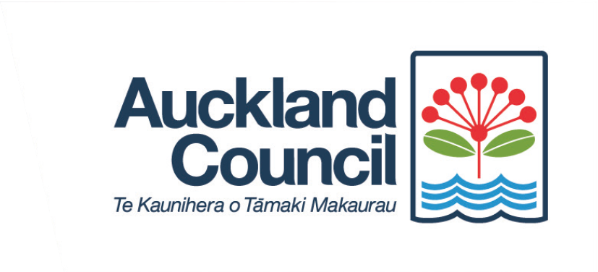

Ngāti Paoa celebrates its Taonga and Whakapapa – Piritahi Marae
Waiheke Island
Sunday 24th July 2016

Ngāti Paoa in partnership with Auckland Council has organised two unique events on Waiheke Island, as part of the Empowered Māori Communities programme – Maramataki Toi Māori.

As the Mana Whenua iwi for Matariki 2016, Ngāti Paoa in partnership with Auckland Council has been curating stories and workshops for all Aucklanders to participate in, and these two workshops are the final part of this year’s programme.
The workshops will be delivered delivered through two segments - a carving workshop about Ngāti Paoa whakapapa at Piritahi Marae with carvers Puhi Thompson and son Hemi and a bus tour on the Island with Moana Clarke that will connect visitors to the oral whakapapa traditions via key sites and events of significance to the Ngāti Paoa people.

Project Manager, Aroha Te Kanawa says both events will help provide an experience around storytelling, waiata, karakia and manaakitanga led by the Ngāti Paoa guides.

“These events are for everyone whether you live on Waiheke Island or are just visiting. It will help provide an understanding of the history of the iwi and what sets them apart from other iwi in Auckland.”

Ngāti Paoa Carver Puhi Thompson and son Hemi says the story of Ngāti Paoa people is special and the workshop will show exactly that.

“Everyone that visits Waiheke Island can feel the power of the land and our carvings reflect that and our history. This is a perfect opportunity to find out more.”

The carving workshop and bus tour will take place on Sunday, 24th July, 2016.

There will be two groups per day so it is important to book.

The Programme is set out below

Session 1- Group One
8.45am Arrive at Piritahi Marae
9.00am Mihi Whakatau
9.30am Kupu ti
10.00am Hikoi Group 1 depart on Mini Bus with Host
10.00am Carving Workshop Begins
12.30midday Lunch at Marae
1.30pm Kia Mutu
Session 2 – Group Two

1.45pm Arrive at Piritahi Marae
2.00pm Mihi Whakatau
2.30pm Kupu ti
3.00pm Hikoi Group 2 depart on Mini Bus
3.00pm Carving Workshop Begins
5.30pm Dinner at Marae
6.30pm Kia mutu

Numbers are limited so we ask you book early.
For more information, contact Aroha Te Kanawa at aroha@tekanawa.co.nz or
027 276 4285

